UJIAN MSQL

NO 1.

mysql> select * from city where CountryCode="IDN" order by population desc limit 10;

+-----+----------------+-------------+------------------+------------+

| ID | Name | CountryCode | District | Population |

+-----+----------------+-------------+------------------+------------+

| 939 | Jakarta | IDN | Jakarta Raya | 9604900 |

| 940 | Surabaya | IDN | East Java | 2663820 |

| 941 | Bandung | IDN | West Java | 2429000 |

| 942 | Medan | IDN | Sumatera Utara | 1843919 |

| 943 | Palembang | IDN | Sumatera Selatan | 1222764 |

| 944 | Tangerang | IDN | West Java | 1198300 |

| 945 | Semarang | IDN | Central Java | 1104405 |

| 946 | Ujung Pandang | IDN | Sulawesi Selatan | 1060257 |

| 947 | Malang | IDN | East Java | 716862 |

| 948 | Bandar Lampung | IDN | Lampung | 680332 |

+-----+----------------+-------------+------------------+------------+

10 rows in set (0.00 sec)

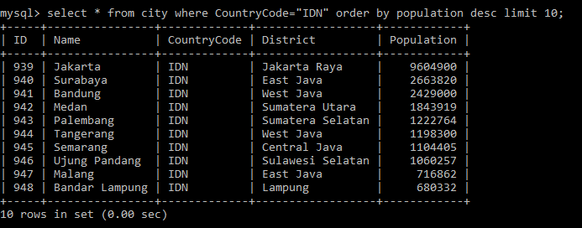

NO 2. BELUM DAPAT JOIN YANG BENAR

mysql> select id, city.name as "nama_kota", district, country.name as "negara, population from city, country where city.CountryCode=country.name order by population desc;

"> ;

"> ;

"> ;

"> ;

"> ;

"> ^C

mysql> select id, city.name as "nama_kota", district, country.name as "negara, population from city, country where city.CountryCode=country.name order by population desc;

"> ^C

mysql> select id, city.name as "nama_kota", district, country.name as "negara", population

-> from city, country

-> where city.CountryCode=country.name

-> order by city.population desc;

ERROR 1052 (23000): Column 'population' in field list is ambiguous

mysql> select id, city.name as "nama_kota", district, country.name as "negara", city.population

-> from city, country

-> where city.CountryCode=country.name

-> order by city.population desc;

Empty set (0.43 sec)

mysql> select id, city.name as "nama_kota", district, country.name as "negara", city.population as "population"

-> from city, country

-> where city.CountryCode=country.name

-> order by city.population desc;

Empty set (0.01 sec)

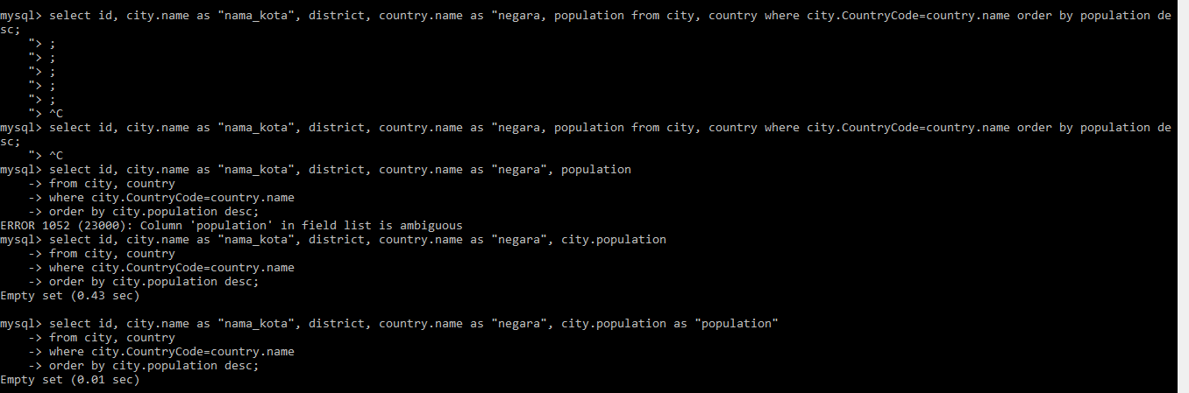

NO 3.

mysql> select Code, Name, Continent, Region, IndepYear as "Tahun_Merdeka" from country where not indepyear="null" order by indepyear limit 10;

+------+----------------+-----------+------------------+---------------+

| Code | Name | Continent | Region | Tahun_Merdeka |

+------+----------------+-----------+------------------+---------------+

| CHN | China | Asia | Eastern Asia | -1523 |

| ETH | Ethiopia | Africa | Eastern Africa | -1000 |

| JPN | Japan | Asia | Eastern Asia | -660 |

| DNK | Denmark | Europe | Nordic Countries | 800 |

| SWE | Sweden | Europe | Nordic Countries | 836 |

| FRA | France | Europe | Western Europe | 843 |

| SMR | San Marino | Europe | Southern Europe | 885 |

| GBR | United Kingdom | Europe | British Islands | 1066 |

| PRT | Portugal | Europe | Southern Europe | 1143 |

| AND | Andorra | Europe | Southern Europe | 1278 |

+------+----------------+-----------+------------------+---------------+

10 rows in set, 1 warning (0.08 sec)

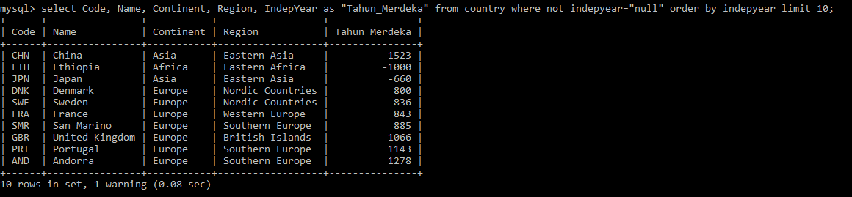

NO 4.

mysql> select continent as "Benua", count(name) as "Jumlah_Negara", sum(Population) as "Populasi", avg(lifeexpectancy) as "Rata_AngkaHrpnHdp" from country where not population=0 group by continent order by sum(population) desc;

+---------------+---------------+------------+-------------------+

| Benua | Jumlah_Negara | Populasi | Rata_AngkaHrpnHdp |

+---------------+---------------+------------+-------------------+

| Asia | 51 | 3705025700 | 67.44118 |

| Africa | 57 | 784475000 | 52.57193 |

| Europe | 46 | 730074600 | 75.14773 |

| North America | 37 | 482993000 | 72.99189 |

| South America | 14 | 345780000 | 70.94615 |

| Oceania | 27 | 30401150 | 69.71500 |

+---------------+---------------+------------+-------------------+

6 rows in set (0.00 sec)